Project Overview
Music Instrument Rental Platform
The goal is to build a Music Instrument Rental Platform where users can browse instruments, request rentals for specific time periods, and manage their bookings. An admin panel allows management of instruments, users, and rental requests.
Requirements (MoSCoW)
Must Have
User Features
User registration and login
Browse instruments
View instrument details (name, category, price, condition, description, image)
Filter and search instruments
Submit rental requests (start date, end date, purpose)
View and cancel own requests
Edit profile
Admin Features
Admin authentication (role-based)
Manage instruments (create, edit, delete, image upload)
Manage categories
View and manage rental requests (approve, reject, complete)
Manage users (block/unblock)
Track instrument availability
System Requirements
Secure password hashing
Session-based authentication
Role-based authorization
Form and input validation
Date validation (no past dates, valid ranges)
Prevent overlapping bookings
Responsive design
Should Have
Availability indicators
Improved profile management
Basic admin statistics
Enhanced search
Better form feedback
Could Have
Automatic cost calculation
Email notifications
Ratings and reviews
Featured instruments
Calendar view
PDF export
Advanced filters
Dark mode
Won’t Have
Mobile apps
Real-time chat
Advanced analytics
Subscription systems
Non-Functional Requirements
Performance
Fast response times
Security
Protection against SQL injection and XSS
Secure session handling
Usability
Clear and intuitive interface
Responsive design
Reliability
Consistent data handling and conflict prevention
Maintainability
Separation of frontend, backend, and database
Data Protection
Minimal data storage and GDPR compliance

- Create user personas - Who will use this system? What are their goals?
Persona | Description | Needs | Pain Points
Maryam | Beginner Student | Affordable short-term instrument rental; Try before buying | Unsure if she will continue learning
Reza | Music Instructor | Fast access to quality instruments for students; Reliable booking flow | Manual rental handling is slow and error-prone
Academy Admin | System Administrator | Centralized control over stock and requests; Structured, auditable operations | Booking conflicts and human mistakes

- Design wireframes - How should the instrument listings look? What's the rental request flow?
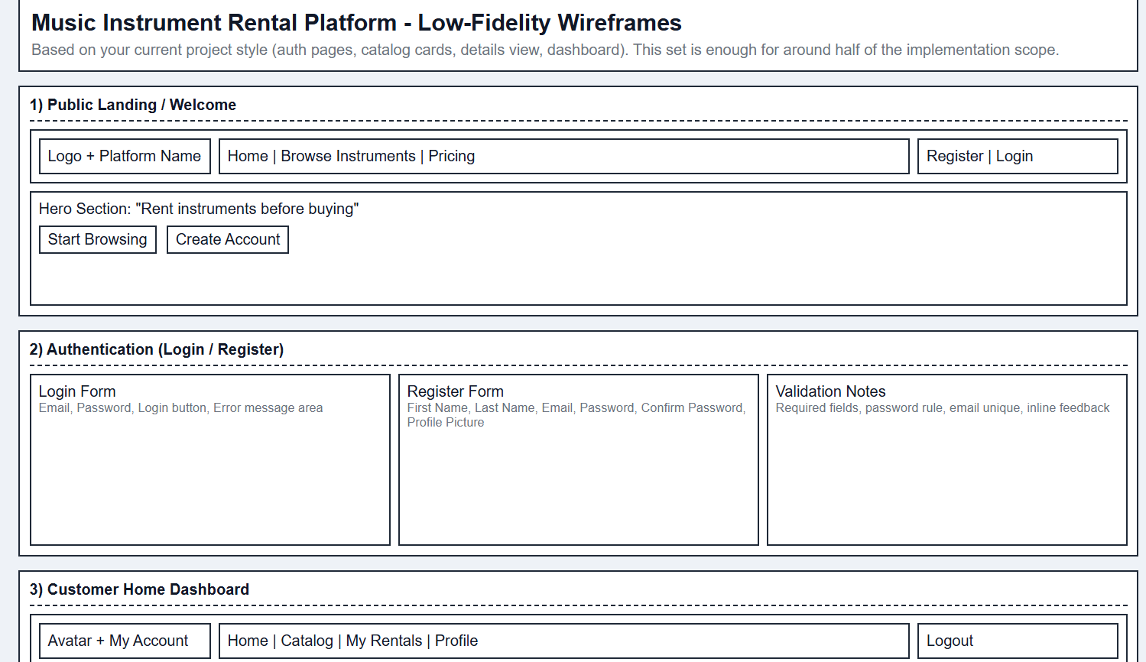

Customer Side
- Instrument Listing (card grid + filters + search)
- Instrument Detail (image, specs, daily price, condition)
- Rental Request Form (start/end date + purpose)
- My Rentals (pending/approved/rejected/completed)

Admin Side
- Admin Dashboard (KPIs + new requests)
- Instrument Management (CRUD + image upload)
- Category Management (CRUD)
- User Management (status and block controls)
- Build an ERD - What database tables do you need? How do they relate?
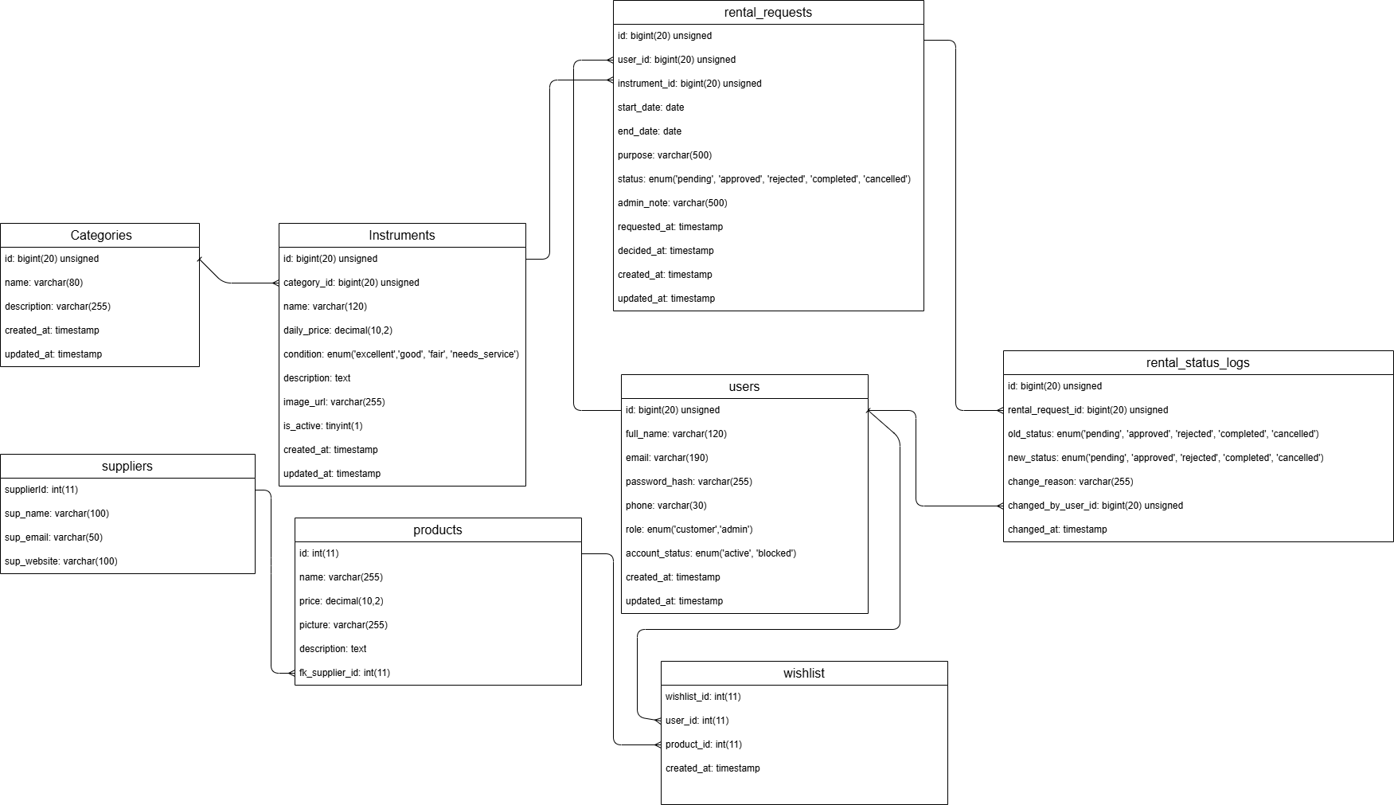
Table | Key Fields | Relationships
users | id, first_name, last_name, email, pass, status | One-to-many with rental_requests, rental_status_logs, wishlist
categories | id, name, description | One-to-many with instruments
instruments | id, category_id, name, daily_price, condition, description, image_url, is_active | Many-to-one with categories, one-to-many with rental_requests
rental_requests | id, user_id, instrument_id, start_date, end_date, purpose, status, admin_note, requested_at, decided_at | Many-to-one with users and instruments, one-to-many with rental_status_logs
rental_status_logs | id, rental_request_id, old_status, new_status, changed_by_user_id, changed_at | Many-to-one with rental_requests and users
products | id, name, price, picture, description, fk_supplier_id | Many-to-one with suppliers, one-to-many with wishlist
suppliers | supplierId, sup_name, sup_email, sup_website | One-to-many with products
wishlist | wishlist_id, user_id, product_id | Many-to-one with users and products

Status values: pending, approved, rejected, completed, cancelled. Date rules and booking overlap checks are enforced in the service layer.
Important Project Logic Points
  - Prevent simultaneous bookings by checking availability in the PHP layer before creating or approving requests
  - Prevent category deletion if linked instruments exist (ON DELETE RESTRICT)
  - Block users from login and requests when account status is set to blocked
  - Ensure secure password handling using password_hash() and password_verify()
  - User Stories with Acceptance Criteria
  - As a user, I want to register and log in securely so that I can manage my rentals
  - Acceptance criteria: passwords are hashed, duplicate email registration is prevented, and a valid session is created
  - As a user, I want to search and filter instruments so that I can quickly find suitable options
  - Acceptance criteria: search by name or category works and only available instruments are shown
  - As a user, I want to request rental dates so that I can reserve an instrument
  - Acceptance criteria: end date is after start date, past dates are rejected, and status is set to pending
  - As an admin, I want to approve or reject requests so that inventory is managed correctly
Acceptance criteria: only pending requests can be processed and a rejection reason can be stored
  - As an admin, I want to mark rentals as completed so that availability is updated
Acceptance criteria: only approved requests can be completed and the instrument becomes available again
  - As a user, I want to view only my rental requests so that my data remains private
Acceptance criteria: users can access only their own data and unauthorized access is blocked
  - As an admin, I want to manage instruments and categories so that the catalog stays accurate
Acceptance criteria: CRUD operations work and category deletion is restricted when linked
  - As an admin, I want to block or unblock users so that misuse can be controlled
Acceptance criteria: blocked users cannot log in or create requests, existing data remains visible
  - As the system, I need to prevent overlapping bookings so that instruments are not double-booked
Acceptance criteria: requests are rejected if they overlap with approved bookings for the same instrument

Sprint Plan
  - Sprint 1
Database design and ERD
Authentication (registration, login, session, roles)
Instrument listing, detail view, search and filtering
Rental request submission with date validation
  - Sprint 2
Admin panel (instrument and category management)
Full rental request workflow (approve, reject, complete)
User management (block and unblock)
My rentals overview and cancellation
Final testing and demo preparation

Technical Requirements
  - Backend: PHP or Symfony
Frontend: HTML, CSS, JavaScript (Bootstrap allowed)
Database: MySQL

Requirements Engineering and Agile Deliverables
  - User Stories
Defined in the format “As a user, I want to…, so that…”
  - Acceptance Criteria
Clear definition of when a feature is complete
  - Entity-Relationship Diagram (ERD)
All tables, primary keys, foreign keys, and relationships defined
  - Wireframes
Sketches of instrument list, detail page, rental form, user dashboard, admin dashboard
  - Sprint Plan
Two sprints with defined goals and tasks
  - Task Board
Use Trello, Jira, or similar
Columns: Backlog, UpNext, InProgress, Done
Backlog must be completed before project start

Research & Inspiration Sources

- Airbnb - https://airbnb.com/ - Booking flow, calendar selection, listing details
- Rent the Runway - https://renttherunway.com/ - Rental marketplace, request system
- Fat Llama - https://fatllama.com/ - Equipment rental platform
- Sparetoolz - https://sparetoolz.com/ - Tool rental platform

Database Design
- dbdiagram.io - https://dbdiagram.io/
- Lucidchart - https://lucidchart.com/
- Database Answers - https://databaseanswers.org/

Wireframe Tools
- Excalidraw - https://excalidraw.com/
- Figma - https://figma.com/
- draw.io - https://draw.io/
- Miro - https://miro.com/
- Pen and paper - Sometimes the fastest option!

UI Component Inspiration
- Start Bootstrap - https://startbootstrap.com/
- Bootstrap Made - https://bootstrapmade.com/
- Colorlib - https://colorlib.com/wp/free-bootstrap-templates/
- ThemeWagon - https://themewagon.com/theme-tag/free/
- Bootsnipp - https://bootsnipp.com/

Icon Libraries
- Font Awesome - https://fontawesome.com/icons
- Heroicons - https://heroicons.com/

Color & Design Tools
- Coolors - https://coolors.co/
- Color Hunt - https://colorhunt.co/
- Adobe Color - https://color.adobe.com/

Typography
Google Fonts - https://fonts.google.com/

Image Resources
- Unsplash - https://unsplash.com/
- Pexels - https://pexels.com/
- Pixabay - https://pixabay.com/
- Lorem Picsum - https://picsum.photos/

Goals
- Build a functional Music Instrument Rental Platform
- User authentication (register, login, logout)
- Browse, search, and filter instruments
- Submit and manage rental requests with valid dates
- Admin panel to manage instruments, users, and rentals
- Prevent overlapping bookings and ensure data integrity

Technical Focus
- Secure backend (PHP or Symfony)
- MySQL database with clear structure (ERD)
- Role-based access control
- Input validation and secure password handling

Risks
- Booking conflicts due to missing validation
- Security vulnerabilities (authentication, data handling)
- Poor database design causing data inconsistency
- Incorrect role/permission handling
- Incomplete or unstable features due to poor planning

Mitigation
- Prioritize core features (MoSCoW)
- Clear sprint planning and task tracking
- Regular testing and validation
- Consistent rules for bookings and user actions
Supporting Techniques
- Mind Mapping
Used to brainstorm ideas and identify stakeholders
- Use Case Diagrams

